**Date**:31/10/2023

**Project ID:**proj_223333_Team_4 **Project Title :**Traffic Management

# Objectives:

**PHASE-5**

**TRAFFIC MANAGEMENT**

* Problem statement
* Smart Traffic Management
* Advanced Traffic Management
* IOT sensor setup
* Mobile App development in Traffic Management
* Flowchart
* Code implementation
* Sollution

# Problem statement :

Traffic Congestion: Developing strategies to alleviate traffic congestion in urban

areas, such as optimizing traffic signal timings or implementing congestion pricing schemes.

# Smart Traffic Management :

Smart Traffic Management integrates real-time data, IoT sensors, and intelligent

algorithms to dynamically regulate traffic signals, reroute vehicles, and provide commuters with accurate information, reducing congestion, minimizing travel time, and promoting a sustainable urban environment."

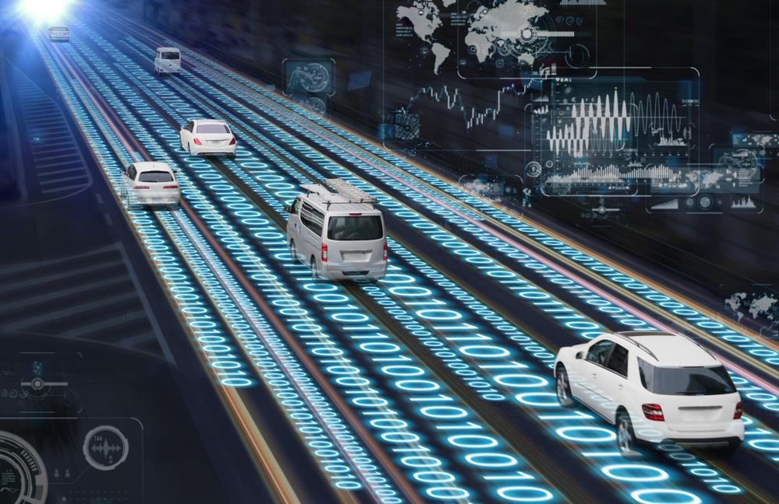

# Advanced Traffic Management :

1. **Data Collection and Analysis:** Advanced Traffic Management systems gather real-time data from various sources such as cameras, sensors embedded in roads, GPS devices, and mobile apps. This data includes information on traffic volume, vehicle speeds, congestion patterns, and accidents. Advanced analytics processes this data to identify trends, predict congestion, and assess traffic conditions.
2. **Intelligent Traffic Control:** Using artificial intelligence and machine learning algorithms, ATM systems analyze the collected data to make informed decisions. These decisions can include dynamically adjusting traffic signal timings, controlling traffic flow at intersections, and rerouting vehicles to optimize overall traffic patterns. Smart traffic signals can adapt in real-time based on the current traffic conditions, ensuring efficient movement of vehicles.
3. **Predictive Analytics:** Advanced Traffic Management systems utilize predictive analytics to forecast traffic congestion and potential issues. By analyzing historical and real-time data, these systems can predict traffic patterns and identify areas prone to congestion at specific times. This information allows authorities to take proactive measures, such as adjusting

traffic flow before congestion occurs.

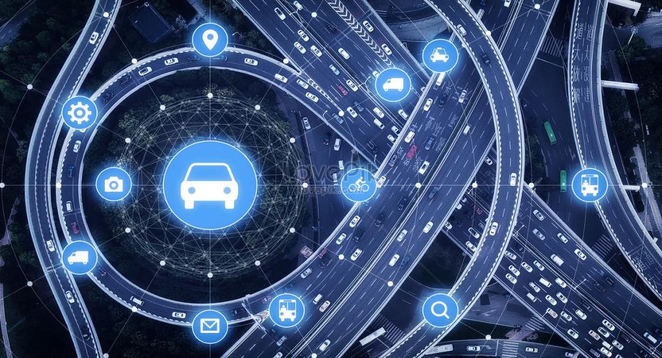

1. **Smart Infrastructure:** Integrating smart infrastructure elements, such as smart traffic lights, adaptive traffic signals, and connected vehicles, enables real-time communication between various components of the traffic system. This interconnectedness allows for

coordinated traffic management strategies, leading to reduced congestion and improved traffic flow.

1. **Communication and Information Dissemination:** Advanced Traffic Management systems facilitate communication with drivers through dynamic message signs, mobile apps, and

other platforms. By providing real-time information about traffic conditions, alternative routes, and expected delays, drivers can make informed decisions, reducing the overall impact of congestion.

1. **Environmental Considerations:** ATM solutions often focus on minimizing the

environmental impact of traffic. By optimizing traffic flow and reducing congestion, vehicles spend less time idling, leading to lower emissions and reduced fuel consumption,

contributing to a greener and more sustainable environment.

# IOT sensors Setup :

1. **Identify the Parameters:** Determine what data you want to collect. This can include vehicle count, speed, traffic density, weather conditions, and more.
2. **Choose the Right Sensors:** Select appropriate sensors for each parameter. For instance, use traffic cameras for visual data, inductive loop sensors embedded in roads for vehicle count, and weather sensors for weather conditions.
3. **Connectivity:** Ensure there's a reliable network connection (Wi-Fi, cellular, or LPWAN like LoRaWAN) to transmit data from the sensors to a central server or cloud platform.
4. **Data Processing and Storage:** Set up a system to process and store the incoming data. Cloud platforms like AWS, Azure, or Google Cloud provide services for data storage, processing, and analytics.
5. **Data Analysis:** Implement algorithms and data analytics tools to derive meaningful insights from the collected data. This can include identifying traffic patterns, congestion points, and predicting traffic flow.
6. **Visualization and User Interface**: Develop a user-friendly interface (web or mobile app) for visualizing the data in real-time. Graphs, maps, and other visualizations help stakeholders understand the traffic situation easily.
7. **Automation and Control:** Implement automation systems based on the collected data. For instance, intelligent traffic lights that adjust timings based on traffic flow.
8. **Security:** Ensure data security and privacy. Implement encryption and access control mechanisms to protect sensitive traffic data from unauthorized access.
9. **Maintenance and Monitoring:** Regularly maintain the sensors and the entire IoT infrastructure. Implement monitoring systems to detect and address issues promptly.

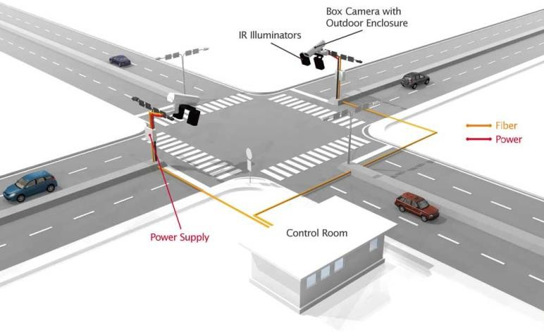

1. **Integration:** Integrate the traffic management system with other city infrastructure systems, such as emergency services, to optimize responses during incidents.

# Mobile Development in Traffic Management :

Mobile development in traffic management involves creating applications that facilitate efficient traffic control, enhance safety, and provide real-time information to both authorities and commuters

1. **Navigation and Routing:** Apps can offer optimal routes to drivers based on real-time traffic data, helping them avoid congested areas and reduce travel time.
2. **Traffic Monitoring:** Mobile apps can collect and analyze data from various sources like GPS, traffic cameras, and sensors to monitor traffic flow. This information can be used to identify congestion patterns and manage traffic signals accordingly.
3. **Public Transportation Integration:** Integrating public transportation schedules, routes, and real-time tracking can encourage the use of public transport, reducing the number of private vehicles on the road.
4. **Emergency Alerts:** Sending real-time alerts to drivers about accidents, road closures, or other emergencies can help them make informed decisions about their routes.
5. **Parking Assistance:** Apps can provide information about available parking spaces, helping drivers find parking quickly and reducing unnecessary traffic caused by drivers searching for parking spots.
6. **Predictive Analytics**: By analyzing historical traffic data, machine learning algorithms can predict traffic patterns and help authorities plan better traffic management strategies.
7. **Traffic Law Compliance:** Mobile apps can remind drivers of speed limits, notify them about no-entry zones, and discourage distracted driving, contributing to overall road safety.

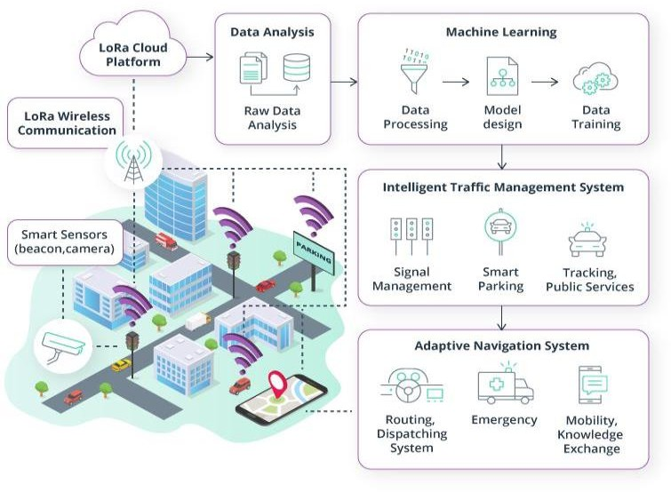

1. **Community Engagement:** Apps can enable users to report road issues, accidents, or other incidents, fostering a sense of community involvement in traffic management.
2. **Integration with Smart Infrastructure:** Mobile apps can communicate with smart traffic lights, sensors, and other infrastructure to optimize traffic flow based on real-time conditions.
3. **Data Analytics and Visualization:** Mobile applications can present traffic data in user- friendly formats, helping authorities visualize trends and make data-driven decisions for improving traffic management strategies.

**Flowchart :**

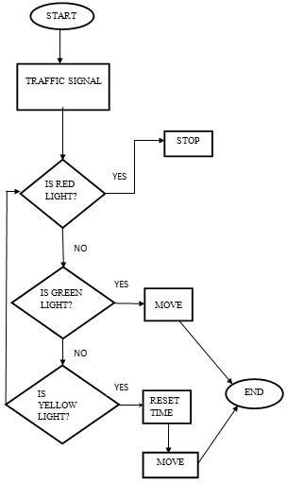

**Code Implementation :**

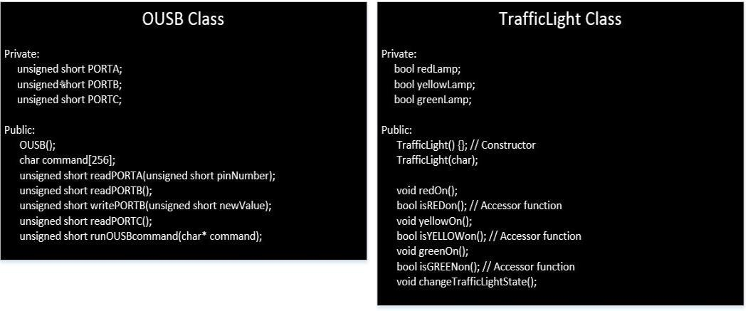

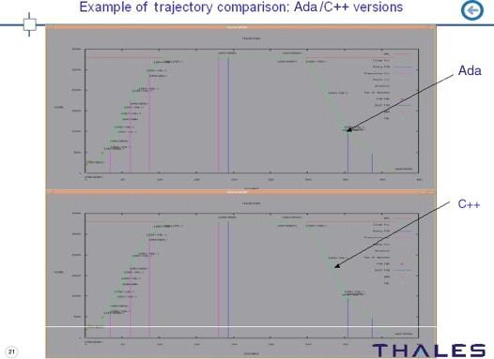

**SOLUTION:**

Traffic Signals and Signs: Properly timed traffic signals and clear road signs help regulate the movement of vehicles and pedestrians.

Traffic Education: Educating the public about traffic rules and safety measures can improve overall adherence to traffic regulations.

Public Transportation: Efficient public transportation systems can reduce the number of private vehicles on the road, easing traffic congestion.

Traffic Monitoring: Using technology such as CCTV cameras and sensors to monitor traffic flow in real-time helps authorities respond quickly to traffic issues.Road Infrastructure: Well- designed roads, bridges, and tunnels can facilitate smoother traffic flow. Investing in road infrastructure upgrades is crucial.

Traffic Planning: Implementing smart traffic planning, including one-way systems and dedicated lanes for different types of vehicles, can optimize traffic flow.

Traffic Enforcement: Strict enforcement of traffic laws, including penalties for violations, encourages compliance among drivers.

Traffic Apps: Mobile applications that provide real-time traffic updates and alternative routes help drivers avoid congested areas.

Green Initiatives: Promoting cycling lanes, pedestrian-friendly zones, and electric vehicles can reduce traffic and environmental impact.

Data Analysis: Analyzing traffic data can identify patterns and bottlenecks, enabling authorities to make informed decisions for traffic management.